**Ideation Phase**

**Define the Problem Statements**

|  |  |
| --- | --- |
| Date | 3 JUNE 2025 |
| Team ID | LTVIP2025TMID33800 |
| Project Name | TrafficTelligence: Advanced Traffic Volume Estimation with Machine Learning |
| Maximum Marks | 2 Marks |

**Customer Problem Statement Template:**

Create a problem statement to understand your customer's point of view. The Customer Problem Statement template helps you focus on what matters to create experiences people will love.

A well-articulated customer problem statement allows you and your team to find the ideal solution for the challenges your customers face. Throughout the process, you’ll also be able to empathize with your customers, which helps you better understand how they perceive your product or service.

Reference: <https://miro.com/templates/customer-problem-statement/>

**Example:**

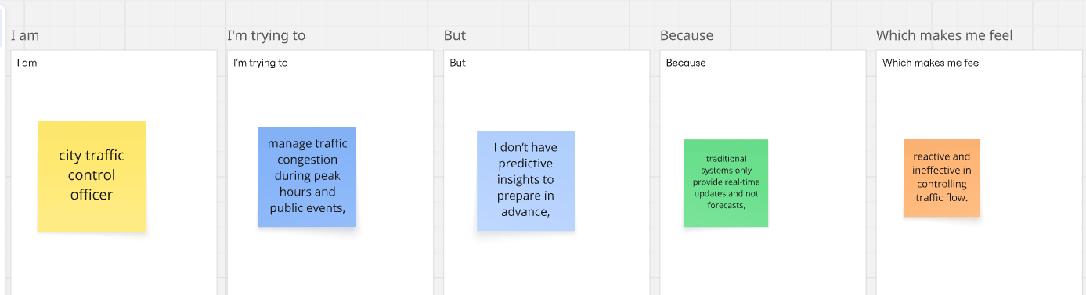

|  |  |  |  |  |  |
| --- | --- | --- | --- | --- | --- |
| **Problem Statement (PS)** | **I am (Customer)** | **I’m trying to** | **But** | **Because** | **Which makes me feel** |
| PS-1 | **I am** a city traffic control officer, | **I’m trying to** manage traffic congestion during peak hours and public events, | **But** I don’t have predictive insights to prepare in advance, | **Because** traditional systems only provide real-time updates and not forecasts, | **Which makes me feel** reactive and ineffective in controlling traffic flow. |
| PS-2 | **I am** a daily commuter in a busy metropolitan city, | **I’m trying to** plan my route to avoid heavy traffic, | **But** I often get stuck in unpredictable traffic jams, | **Because** navigation apps don’t always consider weather or event-based traffic spikes, | **Which makes me feel** frustrated, delayed, and stressed. |